Chapter 10, Solution 42.

Using Fig. 10.87, design a problem to help other students to better understand the superposition theorem.

Although there are many ways to work this problem, this is an example based on the same kind of problem asked in the third edition.

Problem

Solve for I_{o} in the circuit of Fig. 10.87.

I_{o}
j10 Ω 60 Ω
+
_
+
_

50 Ω –j40 Ω
20∠0º V 30∠45º V

Figure 10.87 For Prob. 10.42.

Solution

Let 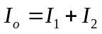
where I₁ and I₂ are due to 20<0º and 30<45º sources respectively. To get I₁, we use the circuit below.
I₁
j10 Ω 60 Ω
+
_

50 Ω –j40 Ω
20∠0º V

Let Z₁ = -j40//60 = 18.4615 –j27.6927, Z₂ = j10//50=1.9231 + j9.615
Transforming the voltage source to a current source leads to the circuit below.

I₁

Z₂ Z₁
–j2

Using current division,
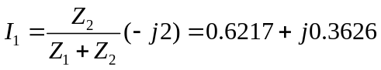
To get I₂, we use the circuit below.

I₂
j10 Ω 60 Ω
+
_

50 Ω –j40 Ω
30∠45º V

After transforming the voltage source, we obtain the circuit below.

I₂

Z₂ Z₁
0.5∠45º

Using current division,
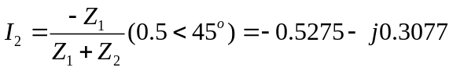

Hence, I_{o} = I₁ + I₂ = 0.0942+j0.0509 = 109∠30° mA.

